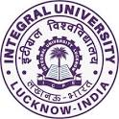

**Integral University, Lucknow**

**Department of Chemistry**

**Slogan Writing on “Gender equity at Workplace”**

**Date: 12th October 2022**

**REPORT**

To promote a healthy environment at the workplace and its effect on the fruitful outcome, the Department of Chemistry, Integral university organised a slogan activity on “Gender equality at the workplace” on 12th October 2022 at 12:30 pm. The activity aligned with the **Sustainable Development Goal (SDG) 5** which states that gender equality is essential for a peaceful and prosperous world. The students of the Department participated in this activity and came up with wonderful slogans on the given topic. The activity was coordinated and judged by Dr. Tahmeena Khan, Assistant Professor, Department of Chemistry. The participating students prepared and presented their slogans beautifully, on the instructed medium which were displayed on the soft board of the department and were open to all. Students further discussed how equality amongst all genders is important for a healthy and prosperous environment and how this impact the outcome in any field. Overall it was a good learning experience for the students. The winners of the activity are as follows:

1. Mohd. Arsh Khan (B.Sc. (H) Industrial Chemistry)
2. Sophia (M.Sc. Chemistry)
3. Priyanjali Kaushal (B.Sc. (H) Industrial Chemistry)

**The event at a glance**

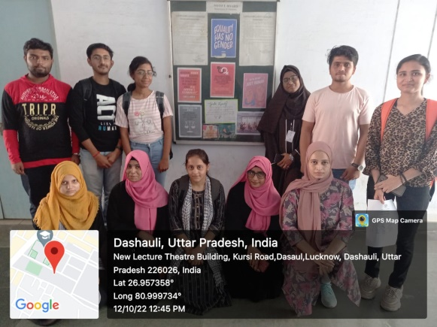 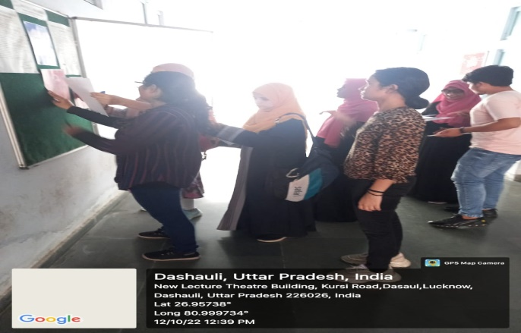

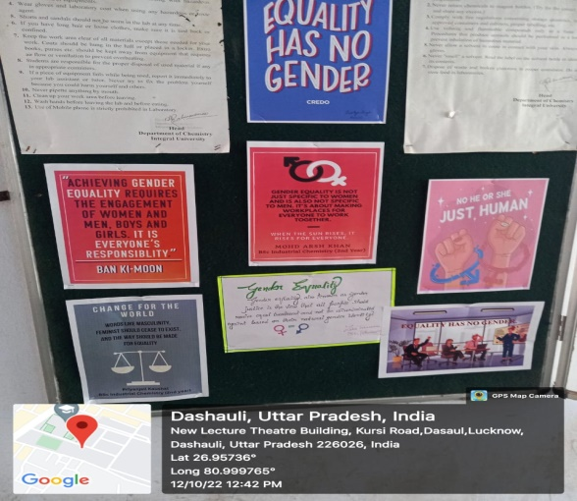 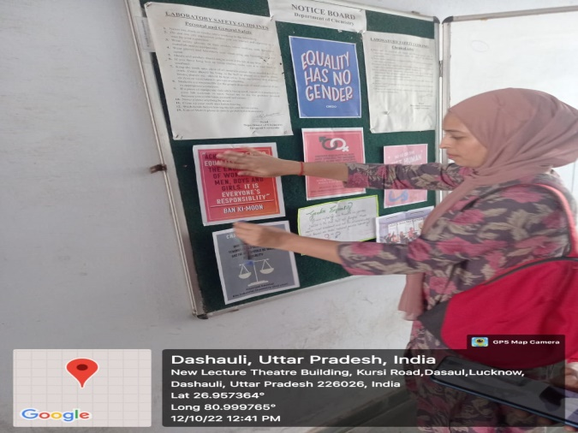

Submitted by:

Dr. Tahmeena Khan